Bike Sales Excel Dashboard

Original Data



Data cleaning: Changed column type, removed unneeded columns, created new age category column, fixed “other” items.

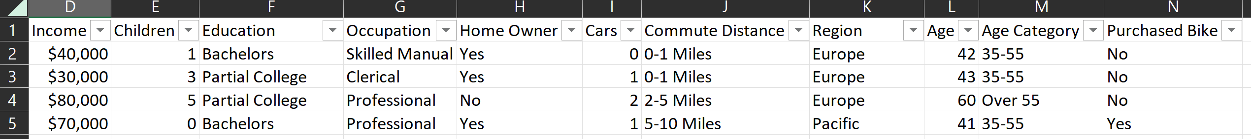

Pivot tables: created pivot tables and charts.

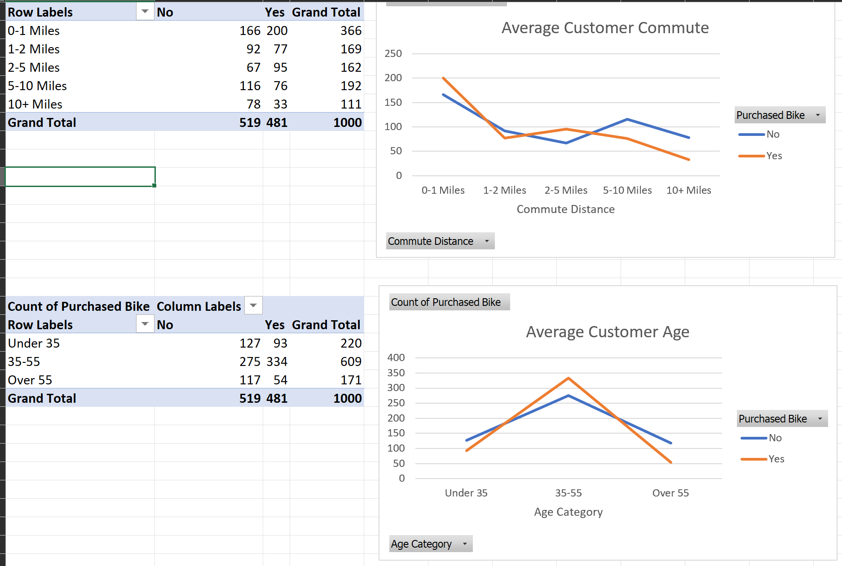

Excel dashboard: created dashboard with filters.

